
REG NO:
DATE: 13-04-19

ST. JOSEPH’S COLLEGE (AUTONOMOUS), BANGALORE-27
B.Sc. BIOTECHNOLOGY - IV SEMESTER
SEMESTER EXAMINATION: APRIL 2019
BT4115 - Molecular Biology

Time- 1 1/2 hrs Max Marks-35
This paper contains TWO printed pages and TWO parts

Part A: Answer any SEVEN of the following 7X2=14 Marks

- Proteins contain many chemical groups apart from standard amino acids. When and how are they added to proteins? Give a specific example of such chemical additions and the enzymes.
- Which repair process in bacteria involves a helicase and a DNA polymerase? Which protein plays the role of the helicase in this process? Explain its specific function in one sentence.
- Carefully observe the following base-pair of A=T. What is the difference between this AT base-pair and an AT base-pair found in normal DNA, with respect to the position of Hydrogen bonds?
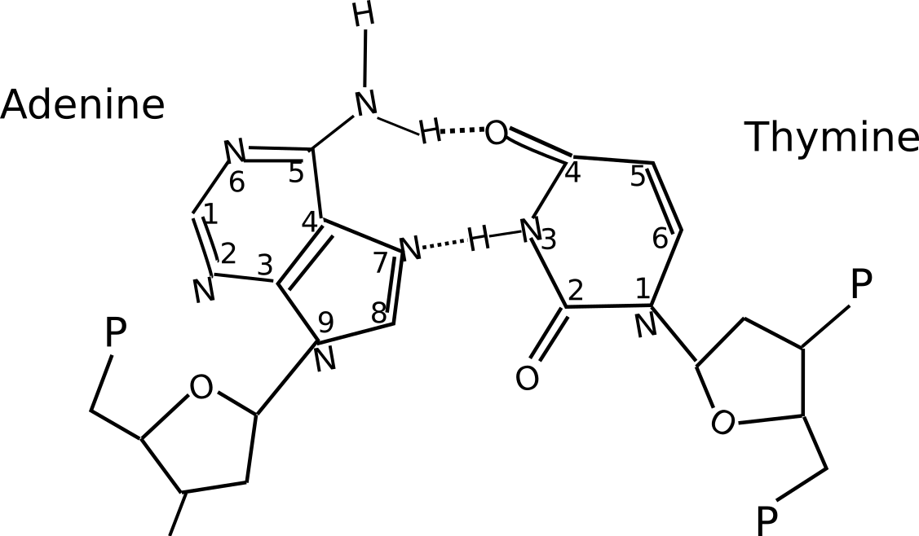
- What is the importance of the beta clamp? How does it function?
- List the components of LacZ gene and their respective protein products.
- List the core promoter components of RNA polymerase II.
- How would prokaryotic transcription be affected if there was no sigma factor?
- Write the reactions involving amino-acylation of tRNA.
- State two important consequences of DNA methylation.
- Imagine that you are Oswald Avery. You have extracted a fraction of macromolecules from the famous S cells. This fraction can transform R cells into infective S cells. To find out what macromolecule does the fraction contain, you performed a chemical analysis. You found that the fraction contains only Carbon, Oxygen, and Hydrogen atoms in the ratio 6 : 5.5 : 11, but NO Phosphorus and Nitrogen.
  - Which macromolecules are NOT LIKELY to be the transforming principle? Explain why in two sentences.
  - Which macromolecule is LIKELY to be the transforming principle. Explain why in two sentences.

Part B: Answer any THREE of the following 3x7=21 Marks

- Answer the following questions about mRNA splicing:
  - Describe mRNA splicing with a simple schematic diagram of a gene and mRNAs.
  - Name the major molecular factors involved in mRNA splicing and their specific roles.
  - Explain the process of alternate splicing with schematic diagram of a gene, mature mRNAs, and proteins.
- Some bacteria of Streptomyces genus have linear chromosomes. Answer the following question with help of diagrams:
  - Which process involved in DNA replication and division of E. coli will not be required in Streptomyces. Why?
  - Which problem will be uniquely faced by Streptomyces (but not E. coli) while replicating its DNA. Why?
- Explain what is a mismatch mutation (with a schematic diagram), two causes of mismatch mutations, and two processes that repair mismatch mutations in E. coli (with a schematic). Include the specific proteins/enzymes and their functions involved in the two repair processes.
- Describe in detail the functioning of Lac repressor in presence and absence of lactose with suitable diagrams.
- Describe the elongation step of prokaryotic translation in detail with suitable diagrams. Write a note on the function of peptidyl transferase.

BT4115_B_19

