
Register Number:

Date:

ST. JOSEPH’S COLLEGE ( AUTONOMOUS), BANGALORE-27
B.Com – IV SEMESTER
SEMESTER EXAMINATION:APRIL 2019
BC4316: E-Commerce

Hours: 11/2 hrs Total Marks: 35
This paper contains one printed sheet and four parts

Section A
I. Answer any five questions, each question carries one marks (5x1=5)

- What is search engine branding?
- What do you mean by affiliate marketing?
- Give few reasons why e-business’s fail.
- What activities of e- commerce can be outsourced?
- What does knowledge building mean?
- Define competitive intelligence.
- State the E-commerce perspectives.

Section B
II. Answer any one questions, each question carries five marks (1x5=5)

- Briefly explain the different ways to finance an e-venture.
- What does ERP stand for? Briefly explain the importance of an ERP system for a company.

Section C
III. Answer any one questions, each question carries ten marks (1x10=10)

- What are the Factors that managers should consider when making a build, buy, or rent decision?
11. What are steps involved in starting a new e-venture.

Section D

IV. 12. Answer the question given below the question carries fifteen marks (compulsory) (1x15=15)

Edible Arrangements had a fairly typical marketing challenge. They offer customers a same-day delivery option (and have done so for years) but people weren’t taking advantage of the offer because they didn’t know about it.
To educate customers about this option they significantly increased visibility with a large banner in an extremely prominent position on the homepage, just below the navigation bar. This created urgency around the offer by featuring a countdown timer to the deadline for same day delivery. It was impossible to miss or misunderstand.
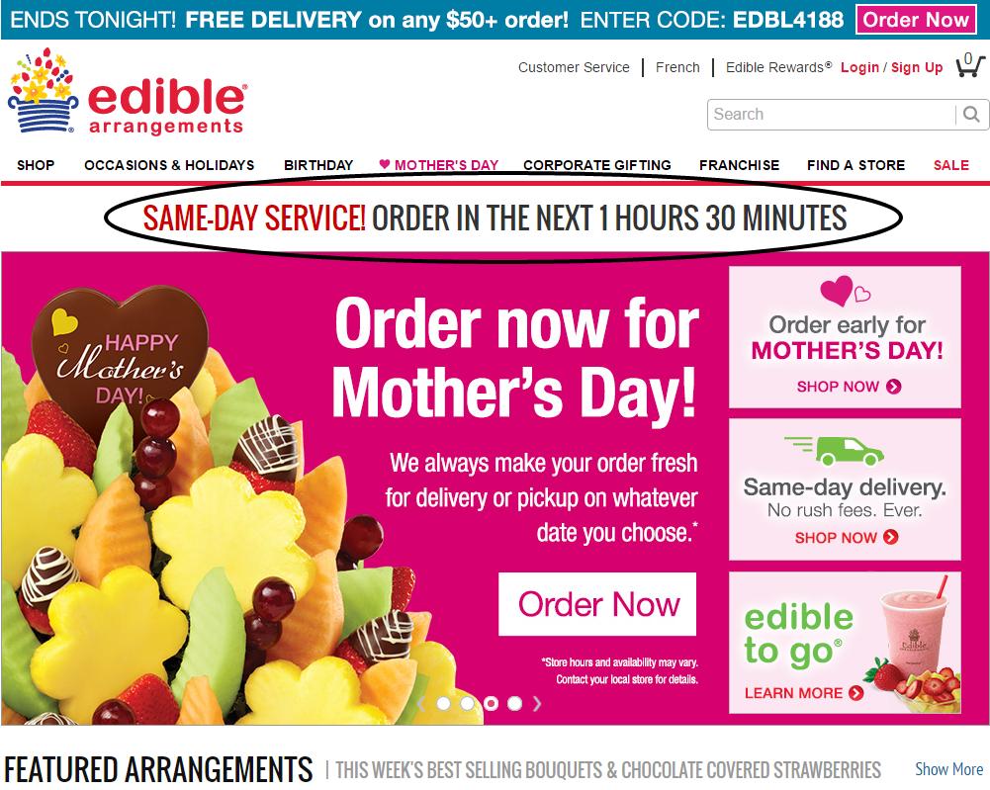

- What are the highlighted elements that you can see in the above website? (5)
- What are the various Advertising and promotion strategies that can be used by them to improve their business? (10)

