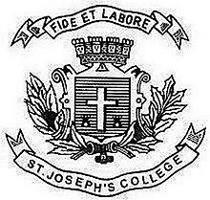
Register No:
Date:

ST. JOSEPH’S COLLEGE (AUTONOMOUS), BANGALORE-27
BVOC FILMMAKING/ ANIMATION - IV SEMESTER
SEMESTER EXAMINATION: APRIL 2019
VO 4216 COMMUNICATION SKILLS – IV

Time: 2 ½ Hrs Maximum Marks:70

This question paper has ONE printed page and THREE parts

- Answer any FOUR in not more than 100 words each (4x5 = 20)
- Product Placement
- Marketing
- Advocacy in Advertising
- CSR
- Press Release and PR
- PRSI

- Answer any TWO questions in about 200 words each (2x 10= 20)
7. What are the principles of Public relations?
8. Explain the stages of Public relations.
9. Elucidate on the practices of a PR professional.

- Answer any TWO of the following questions in about 400 words (2 x 15 = 30)
10. What are the characteristics of corporate communciation? Explain.
11. Design a PSA for Indian Tourism and create a strategy for a campaign.
12. Elaborate on different tools of Public Relations.

*********
VO_4216_B

