Register Number:
DATE: 13-04-2019

ST. JOSEPH’S COLLEGE (AUTONOMOUS), BANGALORE-27
BA VISUAL COMMUNICATION– IV SEMESTER
END SEMESTER EXAMINATION: APRIL 2019

VC 4217: Writing For Media

Time – 2 ^{1/2} hrs Max Marks-70

This paper contains TWO printed pages and THREE parts

- Answer any FIVE of the following question in 100 words each. (5X5 = 25 marks)

1. Write a short note on the following:
a. Teaser
b. Signposting
c. POV
d. Pictography
e. AD LIB
2. Discuss the evolution of writing.
3. Discuss the 3 formats for TV commercials.
4. Discuss 3 tools employed in PR and publicity.
5. Discuss the 2 kinds of reality show?
6. Discuss the guidelines to writing for the web?

- Answer any THREE of the following question in 300 words. (3X10 = 30 marks)
7. Write a press release for the following:
You will prepare a press release to the Anytown Times, the weekly local newspaper, exposing the source of the contamination. Your press release must be written to appeal to the editor of the newspaper as well as the general public who will ultimately read the story. A press release communicates a news story at the same time it promotes your organization. Although it is important for the citizens of Anytown to be aware of the contamination of their river, you also want to use the reporting of your findings to advertise the virtues of the Chemistry Program at Anytown U in a subtle manner.
- Discuss three kinds of layout. Also give a copy for the following print ads and mention which layout would suit it the best.
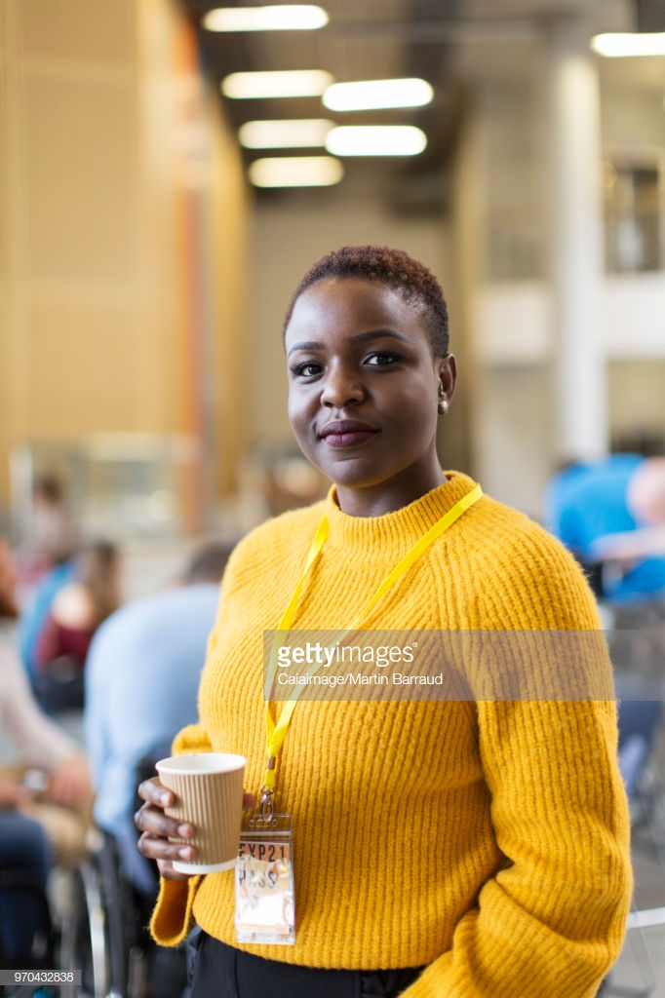
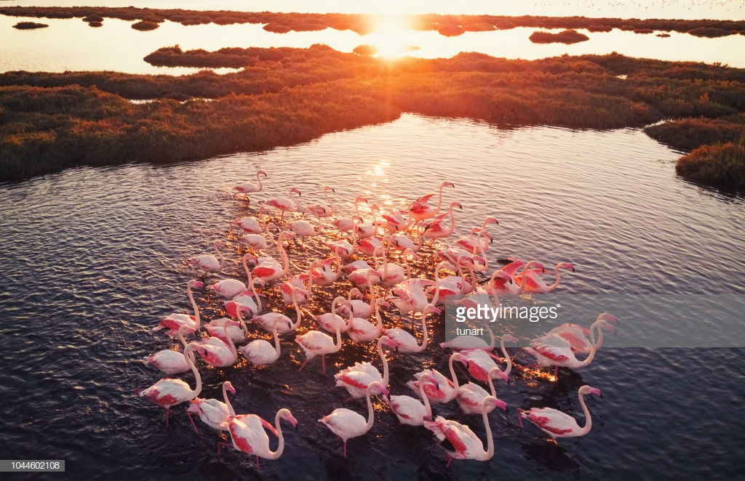

9. Write a blog for the opening of ‘Rosewood’ bread & breakfast near Cubbon Park, Bengaluru.

10. Discuss the five types of headline for a print ad.

- Answer the following question. (1X15 = 15 marks)

11. Write a radio script for a PSA on the harm of using plastic bags for 60 seconds.

VC 4217_A_19

