Reg No

Date:

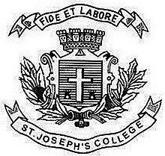
ST. JOSEPH’S COLLEGE (AUTONOMOUS), BANGALORE-27
BCA - II SEMESTER
SEMESTER EXAMINATION: APRIL 2019
CA 2318- Operating System
Time- 2 1/2 hrs Max Marks-70
This paper contains ONE printed page
I.ANSWER ALL THE QUESTIONS(10*2=20)
- Define Operating System
- What are System Calls
- What is the difference between Multi programming and Multitasking
- Define Spooling
- What is a Deadlock
- Differentiate Preemptive and non preemptive process
- What is a Process
- What is Thrashing
- Write the need for Disk Scheduling
- What is a File System
II.ANSWER ANY FIVE QUESTIONS(5*6=30)
- Explain the Life Cycle of a Process in detail
- What is Scheduling ? Explain Long term scheduling and Short term Scheduling
- How do you Detect that a Deadlock has occurred?
- What is Demand Paging.
- Explain the different types of Operating System .
- Discuss Free space Management
- What is Memory ? Explain Memory Allocation .
III.ANSWER ANY TWO QUESTIONS(10*2=20)
- Discuss any two page replacement Algorithm in detail
- What is SJF Scheduling? Explain PRIORITY Scheduling in detail with an example.
- a) Explain the Life Cycle of Process in detail.
b)Memory Management Commands

