
Register Number:
DATE: 12-4-19

ST. JOSEPH’S COLLEGE (AUTONOMOUS), BANGALORE-27
B.Sc. ELECTRONICS– II SEMESTER
SEMESTER EXAMINATION: APRIL 2019
EL 218 : Amplifiers and Oscillators

Time- 2 ½ hrs Max Marks-70

This paper contains three printed pages and three parts
PART-A
Answer any five questions. 5X8=40
- Draw a neat circuit of two stage RC coupled amplifier and derive its voltage gain with the help of its equivalent circuit.

- Explain class B push pull amplifier circuit and derive its efficiency. What is meant by cross over distortion?

- a) Draw a Wein bridge oscillator circuit and explain its working.
b) Sketch and describe the block diagram of IC555.
(4+4)
- a) Explain the working of an astable multivibrator using transistors and derive its frequency of oscillation.
b) Draw the circuit for a voltage-controlled oscillator and give the expression for its output resonant frequency.
(6+2)
- Draw a dual input balanced output differential amplifier and arrive at its differential voltage gain.

- a) Draw block diagram of operational amplifier and explain its working.
b) Write circuit diagram for op amp inverting amplifier and derive its closed loop voltage gain.
(4+4)
- a) Write the circuit for an op-amp integrator and derive its output voltage. Draw the output waveform when the condition RC>>T is fulfilled.
b) With the help of a circuit explain the first order high pass filter and plot the frequency response curve. (4+4)

PART-B
Answer any five questions: 5X4=20
- Determine I_{B}, I_{E}, V_{B} and V_{C} for the Darlington transistor circuit given below.
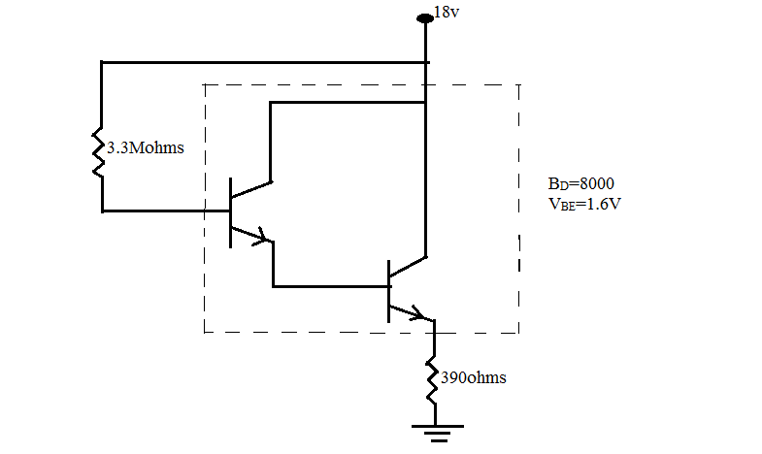

- A power transistor working as class A amplifier is supplied from DC supply of 10V. If the maximum collector current is 50mA, find the power transferred to 4Ω speaker when connected to the transistor through a transformer directly. Determine efficiency?

- Hartley oscillator using split inductance of 2:1 ratio has an output of 450KHz with a capacitance of 20.9pf .Determine the corresponding inductance values.

- Determine the minimum and maximum frequencies for the given circuit.
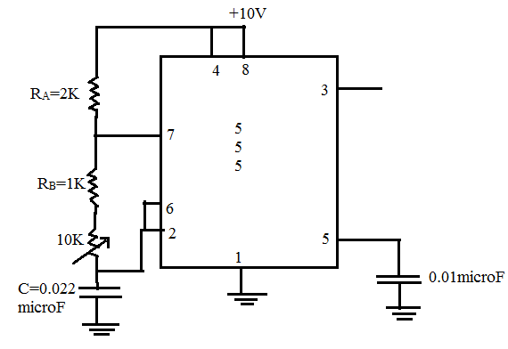

- The 741 IC op-amp having following parameters is connected as a non-Inverting amplifier with R₁=2kΩ, R_{f}=20kΩ, A=200000, R_{i}=1MΩ, R_{o}=75Ω and f_{o}=10Hz. Calculate A_{f}, R_{if},R_{0f,} F_{f}.

- Determine the output voltage for the given circuit. (All resistors shown are equal)
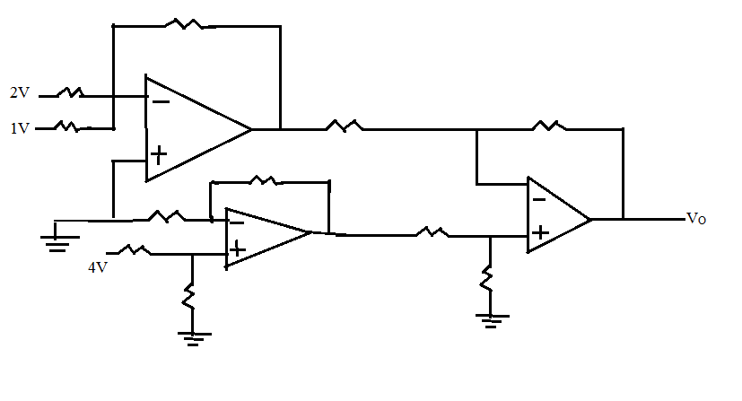
- Design a low pass filter for a mid-band gain of 9 and cut off frequency of 12 KHz.

PART- C
Answer any 5 questions: 5x2=10
- Class C power amplifier is also known as tuned amplifier. Substantiate.
- Can we use 2 sections of RC in a Phase shift oscillator? Give reasons.
- Which multivibrator is called a one-bit memory device and why?
- LM317 IC regulator is better than 78XX series regulators. Explain.
- In a practical high pass filter gain rolls off at around 60KHz frequency. Give reasons.
- Second order Butterworth filters are advantageous over first order filters. Elucidate.
- Explain the significance of CMRR and what should be its ideal value?

------------------------------------------------------

