Register Number:

DATE:



**ST. JOSEPH’S COLLEGE (AUTONOMOUS), BANGALORE-27**

**B.Sc. ELECTRONICS- II SEMESTER**

**SEMESTER EXAMINATION: APRIL 2019**

**EL218: AMPLIFIERS AND OSCILLATORS**

**Time: 2 1/2hrs Max. Marks:70**

This paper contains three printed pages and three parts

**PART – A**

**ANSWER ANY FIVE OF THE FOLLOWING 5 X 8 = 40 marks**

1. a) Draw frequency response of (i) RC coupled (ii) direct coupled and (iii) transformer coupled amplifiers.

b) Draw circuit of Darlington amplifier and derive expression for its current gain. Mention the maximum voltage gain of this amplifier. (3 + 5)

1. a) What is a power amplifier? Illustrate Class-A, Class-B and Cass-C operation of amplifiers using load line diagram.

b) Show that the maximum efficiency of Class -B amplifier is 78.5% (4 +4)

1. a) Mention four types of feedback circuits.

b) State Barkhausen criteria for oscillations.

c) Draw circuit of phase shift oscillator and explain its working. What is the minimum gain required for oscillation in phase shift oscillator? (2+2+4)

1. a) Define astable, monostable and bistable operations of multivibrators.

b) Draw Schmitt trigger circuit using IC555 and explain its working. (3+5)

1. Draw the ac equivalent circuit of a dual input, balanced output differential amplifier and derive expression for its voltage gain.

1. a) Explain the following parameters of operational amplifier.

(i) CMRR (ii) slew rate (iii) input offset voltage (iv) SVRR

b) Draw the circuit of a closed loop non- inverting amplifier and derive expression for its voltage gain. (4+4)

1. a) Draw the circuit of an OP-Amp integrator and derive expression for its output.

b) Differentiate between first order and second order active filters.

c) Explain the working of a low pass filter. (4+2+2)

**PART-B**

**ANSWER ANY FIVE OF THE FOLLOWING 5 X 4 = 20 marks**

1. A class -A power amplifier uses a transistor of maximum power dissipation of 100 mW. The supply voltage is 12 V. Calculate the maximum output ac power and the quiescent collector current assuming the efficiency to be 50%.
2. Calculate the voltage gain of the two stage amplifier.

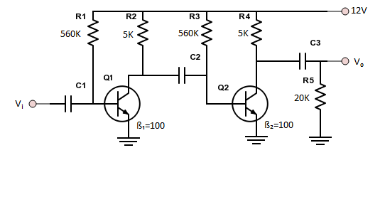

1. A Colpitt”s oscillator uses capacitors C1 = C2 = 100 pF in its tank circuit. The frequency of oscillation is found to be 80 MHz. What would be the frequency if both capacitors replaced to 500 pF?
2. Design and draw a voltage regulator circuit usingLM317 to supply regulated supply of 18 V. Take the lower value of resistor as 1 KΩ.
3. The 741 IC op-amp having following parameters is connected as an inverting amplifier with R1=470Ω, Rf=4.7kΩ, Calculate AF, RIF,R0F, andVooT. A=200000, Ri=2MΩ, Ro=75Ω and fo=5Hz. Supply voltage = ±15V, output voltage swing = ±13V.
4. Calculate Vo1 and Vo2 in the circuit below.

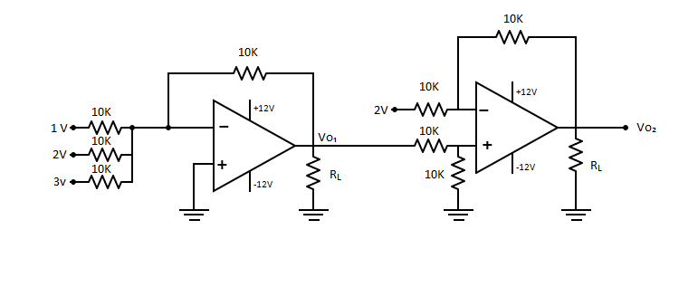

1. Design a Butterworth high pass filter of cut off frequency 4.8KHz and maximum gain of 6. Fix the capacitor value as 0.1 µF.

**PART-C**

**ANSWER ANY FIVE OF THE FOLLOWING 5 X 2 = 10 marks**

1. Two independent single stage amplifiers have voltage gains of A1  and A2 respectively. These amplifiers are direct coupled to form a two stage amplifier. Choose the overall voltage gain from the following(i) A = A1 X A2(ii) A >A1 X A2(iii) A <A1 X A2. Justify your answer.
2. How is that the voltage gain of a tuned amplifier rises at resonance?
3. How does an oscillator give oscillations without any external input signal?
4. How many bits a bistable multivibrator can store?
5. What scale of integration is used in the fabrication a microprocessor IC containing about 10 lakhs components?
6. An operational amplifier can perform mathematical operations.How does it add two numbers?
7. What happens to the gain of an op-amp non-inverting amplifier if the feedback resistor RF is (i)opened (ii) shorted ?

---------------------------------------------