Register Number:
Date: 12/04/2019
ST. JOSEPH’S COLLEGE (AUTONOMOUS), BANGALORE-27
B.A. PSYCHOLOGY - II SEMESTER
SEMESTER EXAMINATION: APRIL 2019
PY213 – BASIC PSYCHOLOGICAL PROCESSES-II

Time- 2 1/2 hrs |  |  | Max Marks-70
This paper contains two printed sides and three parts

SECTION A
- Answer the following questions 10x2= 20
- Define Cognition.
- What is Means-End Analysis?
- What are the three basic dimensions of Intellect?
- What is the formula to calculate IQ?
- What is Homeostasis?
- What are non-verbal emotions? Give 2 examples.
- Define Personality.
- What is the Social Cognitive approach in the study of personality?
- What is the difference between a conference and a symposium?
- Mention any two APA ethical guidelines for research.

SECTION B
- Answer any FOUR of the following 4x5= 20
- What are the processes involved in thinking?
- Elaborate on the emerging trends in intelligence.
- Compare and contrast the Instinct and Drive theories of motivation.
- What are dispositional theories. Explain.
- Describe the experimental method in psychological research.
- What are the characteristics of a good intelligence test?

SECTION C
III. Answer any THREE of the following: 3x10 = 30
- Describe the higher mental processes involved to solve the puzzle given below.
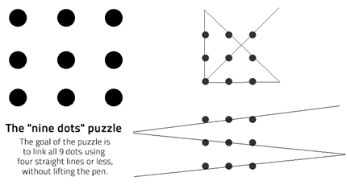

- What are the various theories of intelligence? Explain any two in detail.
- Name the theories of emotions? Explain any two in detail.
- Explain the various techniques used to assess personality. Give the advantages and disadvantages of each.
- What are the steps involved in research? Explain each in brief.

