

DATE:29-6-19

**ST. JOSEPH’S COLLEGE (AUTONOMOUS), BANGALORE-27**

**B.Com– VI SEMESTER**

**Special Supplementary Examination, JUNE 2019**

BCDEM 6616: Advertising

Supplementary candidates only.

Time- 2 ½ hrs Max Marks-70

**This paper contains threeprinted pages and four parts**

**Section A**

I Answer **any five** of the following  **(5 X 2 = 10marks)**

1. What is promotion?
2. Expand DAGMAR.
3. Mention any two objectives of advertising.
4. Explain the term USP.
5. Give the meaning of copywriting.
6. What is the importance of research in advertisement?
7. What is E-Advertising?

**Section B**

II Answer **any three** of the following **(3 x 5 = 15 marks)**

1. Explain Ogilvy’s Brand Image strategy
2. AtoB Co. would like to focus their advertisement efforts on indoor media. Suggest the various options available to them in this field.
3. Given below is a print ad of Sensodyne.

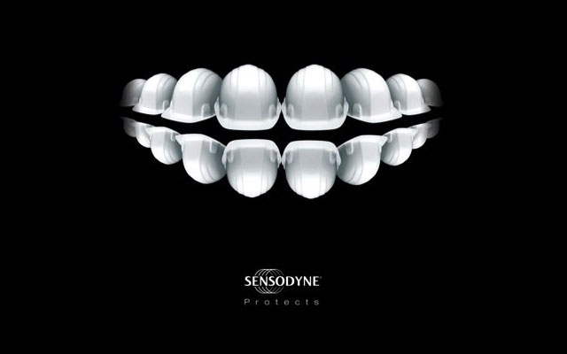

Using this print ad as a point of reference, explain the relationship between advertising and psychology.

1. Why is measuring advertising effectiveness important? Explain the methods of doing the same.
2. Write a note of Sales Effect Test.

**Section C**

III Answer **any three** of the following **(3 x 10 = 30 marks)**

1. Explain the various types of advertising appeals.
2. The Biscuit Inc wants to launch a new brand of coconut cookies, Coco Hearts, in the Indian market. Their biggest competitor is Nice Time Cookies manufactured by Britannia. You are required to:
   1. Create an advertisement copy for this product
   2. Explain why your copy should be selected
3. Write a note on the various media planning, selection and scheduling strategies.
4. FifiInc is setting up a luxury pet grooming service in Bangalore in the summer of 2019. The company has decided to invest in a summer long ad campaign. What are the various steps to be undertaken in an advertisement campaign?
5. According to a 2004 report of the American Psychological Association (APA), “*If is estimated that advertisers spend more than $12 billion per year to reach the youth market and children view more than 40000 commercials each year.”* Discuss the ethical aspects of advertising to children.

**Section D**

IV **Compulsory Question (1 X 15 = 15 marks)**

1. The #MeToo movement is a movement against sexual harassment and sexual assult that began to spread virally in October 2017. This social media hastag was an attempt to demonstrate the widespread prevalence of sexual assult and harassment, especially in the workplace.

Engaging with the #MeToo movement, P&G launched a new campaign for its brand Gillette addressing the issue of Toxic Masculinity. Toxic Masculinity is a term used to describe narrow repressive type of ideas about the male gender role, that defines masculinity as exaggerated masculine traits like being violent, unemotional, [sexually aggressive](https://www.urbandictionary.com/define.php?term=sexually%20aggressive), and so on.

The new Gillette ad campaign focuses on its 30-year tagline “***The best a man can get***”, replacing it with “***The best men can be***”.

The advertisement features news clips of reporting on the #MeToomovement, as well as images showing sexism in films, in boardrooms, and of violence between boys, with a voice over saying: “Bullying, the MeToo movement against sexual harassment, toxic masculinity, is this the best a man can get?”It tackles bullying, sexual harassment, inequality in the workplace, and sexism on screen, by promoting courage, humility, responsibility, and kindness.

The film, called We Believe: the Best Men Can Be, immediately went viral with more than 4 million views on YouTube in 48 hours and generated both lavish praise and angry criticism.

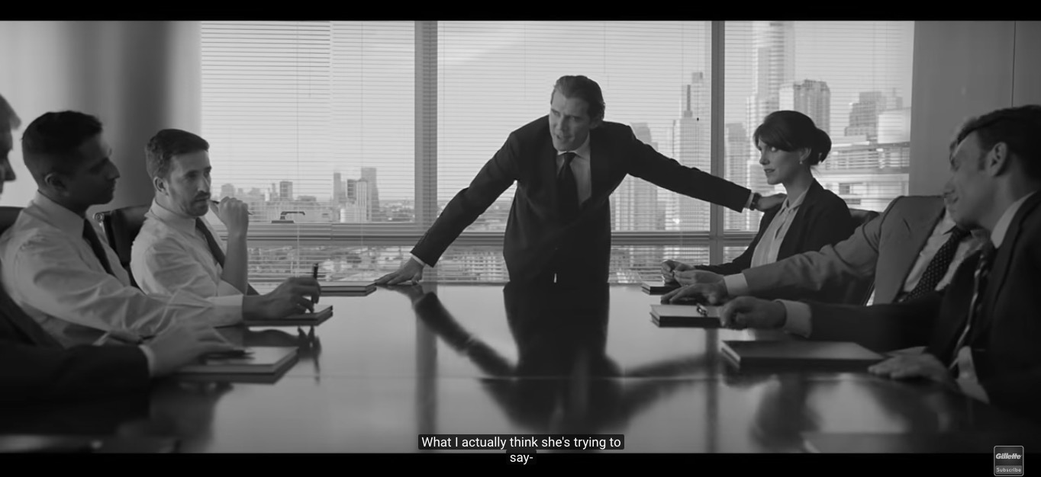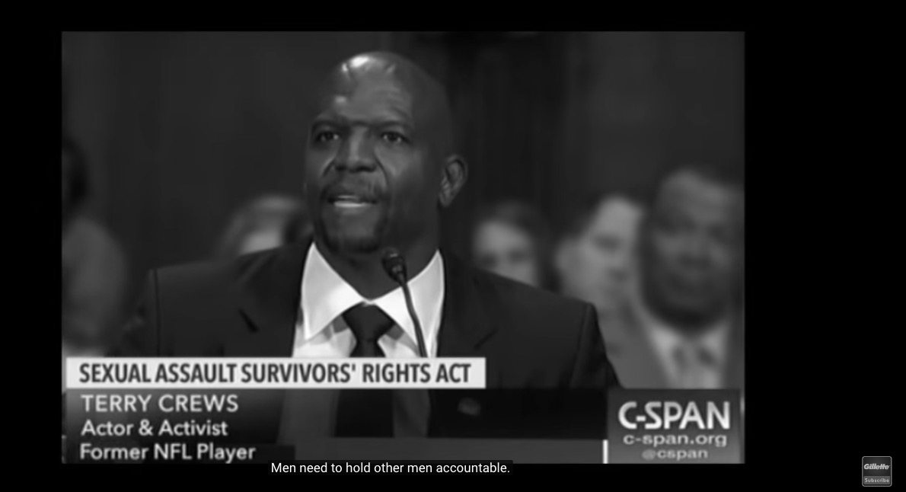

*(Subtitle: What I think she’s trying to say is…)* (*Subtitle: Men need to hold other men accountable)*

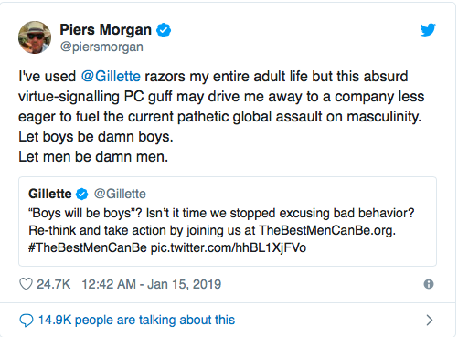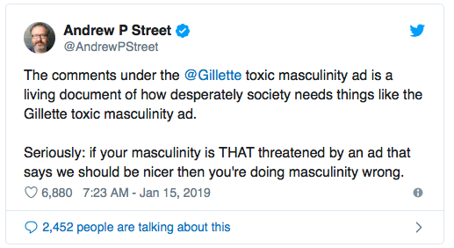

**Questions**

1. In the light of the Gillett campaign, what are the benefits and pitfalls of advertising on social media?
2. Critically examine whether advertisers should include social messages in their ad campaigns.
3. What could be the reasons for this ad facing such a huge backlash?

**(6+6+3)**

**\*\*\*\*\*\*\*\*\*\*\*\*\*\*\*\*\*\*\*\*\*\*\*\*\*\*\*\*\*\***