Register Number:
DATE:
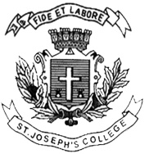
ST. JOSEPH’S COLLEGE (AUTONOMOUS), BENGALURU-27
M.S.W - IV SEMESTER
SEMESTER EXAMINATION: APRIL 2018
SW DE0815 – Disaster Management
Time- 2 1/2 hrs |  |  | Max Marks-70
Part- 1
Answer any five questions. Each question carries 10 Marks: 5x10=50
1. Explain the types of disasters that impact communities.
2. Analyse the impact of disasters on communities. Suggest measures to manage them.
3. Explain the role of relief and rehabilitation in the management of disasters.
4. Illustrate the role of international organisations in the response to disasters.
5. Explain the salient provisions of the Disaster Management Act.
6. What is the role the community social workers in the case of super cyclones?

Part-2
Answer any one question.The question carries 20 Marks. 1x20=20
7. Identify and explain the role of stakeholders in the management of disasters.
8. What skills do social workers require to provide psychosocial support to disaster victims?

