
Registered Number:
DATE: 5 -04-2018 (9AM)
ST. JOSEPH’S COLLEGE (AUTONOMOUS), BENGALURU-27SEMESTER EXAMINATION – APRIL 2018
B.Sc. CBCS – IV Semester
ELOE 4116 Number System and Logic Circuits

Time: 1 Hour and 30 Minutes Max. Marks: 35
This question paper has THREE parts and THREE printed pages.
PART – A
CHOOSE THE CORRECT ANSWER FROM THE OPTIONS GIVEN 10X01=10
1. Way of representing numbers in 0's and 1's form is referred to as

- binary notation b) decimal notation c) hexadecimal notation d) octal notation

2. Which is typically the longest

- Bit b) Byte c) Nibble d) Word

3. Which code is also called unit distance code

- BCD code b) Gray code c) 8421 code d) Excess Three code

4. The next number in the counting of hexadecimal number FFFF is

- FFFF1 b) 1FFFF c) 10000 d) 1000

5. Which gate has the output expression Y = M + N

a) OR gate b) AND gate c) NOT gate d) XOR gate

6. The symbol for two input AND gate is

a) b) c) d)
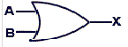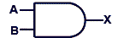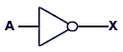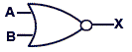

7. The JK Flip flop IC number is

a) 7400 b) 7486 c) 7476 d) 7490

EL OE-416-A-18

8. How many flip flops are required for the ripple counter to count 16 pulses.

a) 32 b) 04 c) 16 d) 08
9. The following symbol is for

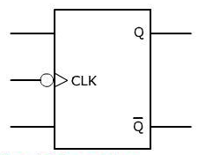
- Level b) Negative edge c) Negative Level d) Positive edge

10. How many Flip Flops are required to store Two bits

a) One b) Two c) Three d) Four

. | PART – B  11 Match the Following 05X01=05  PART – C  Answer any TEN questions. 10X02=20  12. Convert ( 32 ) ₁₆ into Binary.  13. Subtract 37 from 128 using 2’ s complement.  14. Expand ASCII code and how it is different from EXTENDED ASCII.  15. What is a BCD code? Give an example.  16 Write the AND gate circuit with the help of switches and give its truth table.  17. State De Morgan’s theorems.  18 Prove the Boolean identity.  19. Write the output of the circuit given below.  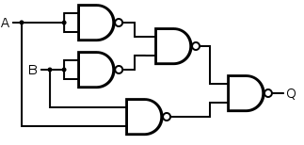  20 Write the symbol of a D Flip flop using SR Flip flop.  21. Write the logic circuit of a 2 bit SISO shift register.  22. Write the truth table for a Decade Counter.  23. Expand RAM and EPROM.  --------------------------------------------------------END------------------------------------------------------------  3.
  a) Binary equivalent of 49 |  | i) NOR gate
  b) 2’ s complement of 011101 |  | ii) Flip Flop
  c) When ODD number of inputs are high,  we get output high |  | iii) 100011
  d) When all inputs are low, we get high  output |  | iv) XOR gate
  e) One bit memory device |  | v) 110001
   |  | vi) 110110

