
Register Number:
DATE:

ST. JOSEPH’S COLLEGE (AUTONOMOUS), BANGALORE-27
BA (VISUAL COMMUNICATION)– IV SEMESTER
END SEMESTER EXAMINATION: APRIL 2018

VC 4217: Writing for Media

Time – 2 ^{1/2} hrs Max Marks-70

This paper contains two printed pages and three parts

- Answer any FIVE of the following question in 100 words. (5X5 = 25 marks)

1. Write a short note on the following:
a. Teaser
b. Tag
c. POV
d. INSERT
e. AD LIB
2. Discuss Robert Mc Leishe’s 7 P’s in radio production.
3. Discuss the three formats for TV commercials.
4. What is the difference between PR and Advertising.
5. What is a Press Release?

6. What is the difference between blogging and micro blogging sites?

- Answer any THREE of the following question in about 300 words. (3X10 = 30 marks)
7. Discuss the six types of body copy.
8. Write copy for the following print ads. Specify the product and provide an explanation.
1. 
2. 
3. 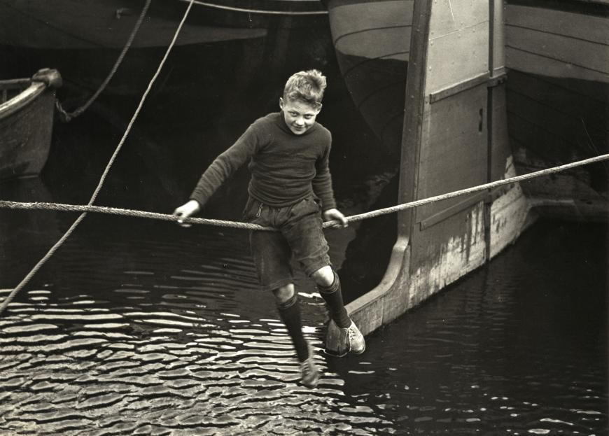
10. Write a blog for the launch of ‘AirPods’ in the market.

11. Write a press release for
In an anonymous communiqué received by the North American animal liberation press office, activists from the Animal Liberation Front (ALF) claim to have rescued 20 rabbits destined for slaughter at blue chip farms, 268 hill top drive in fountain inn.

- Answer the following question. (1X15 = 15 marks)

12. Write a radio script for a 60 seconds PSA on building of toilets.

