
Reg. no.:
Date: 4-04-2018 ( 9 AM )
ST. JOSEPH’S COLLEGE (AUTONOMOUS), BENGALURU-27
OPEN ELECTIVE: IV SEMESTER
SEMESTER EXAMINATION- APRIL 2018
ZO-OE-4116- A Journey in to Animal World and Human Life

Time: 1 ½ hrs Maximum marks: 35

This question paper has two printed pages and three parts

- Answer the following questions. Each question carries 1 mark 10 x 1 = 10

- Define Tidal Volume.

- Mention any two reasons for liver cirrhosis and its prevention.

- Name the major divisions of human nervous system.

- Why are bleeder’s disease and cat cry syndrome called so?

- Name the following. (a). Animal in WWF logo (b). India’s first National Park.

6. What do the following depict with regard to behavioural psychology?

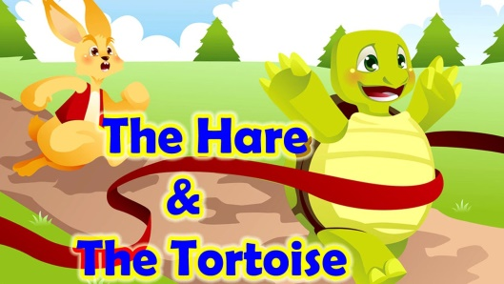 | 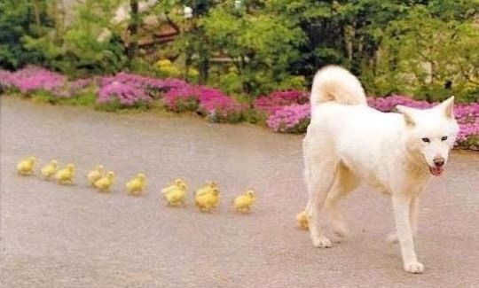

7. Mention any two advantages of Vermicompost.

8. Plasmodium is a protozoic parasite which causes ___________.
9. Which class of animal has skin with scales, lays eggs with a leathery shell and does not maintain a constant body temperature?
10. The five classes of vertebrates are:
- Mammals, Amphibians, Pisces, Birds, Reptiles
- Mammals, Marsupials, Monotremes, Birds, Frogs
- Mammals, Whales, Birds, Amphibians, Reptiles
- Vertebrates, Invertebrates, Birds, Fishes, Reptiles

- Answer any 5 of the following 5 x 2 =10

- Give reasons why blood transfusion should not be given unless there is risk for life.

- Depict the modes of HIV prevention and control.

- Based on the figure answer the following questions.
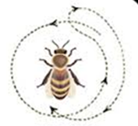 | a. Name the type of dance? b. When is it performed?
4. What is first-aid? Suggest a first aid for a) Choking b) Heart attack.

5. What are the general features of reptiles?
6. Define any three different types of cancer.

- Answer any 3 of the following 3 x 5 = 15

- Illustrate the digestive system and its significance in man.

- Draw a neat labelled diagram, explain the anatomy & functions of human heart.

- Give an example and suggest any two suitable preventive measures for the following
- Human-Animal conflict B. Insect- borne diseases
- Describe the way in which a heart attack is different from a cardiac arrest.
- Write a short note on Diabetes mellitus, types and its causes.

