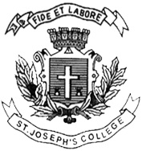

DATE: 19 -04-2018 (1 PM)
ST. JOSEPH’S COLLEGE (AUTONOMOUS), BENGALURU-27
M.Sc. CHEMISTRY: IV SEMESTER
SEMESTER EXAMINATION-APRIL 2018
CH 0415: Solid State Chemistry
(For supplementary candidates)
Do not write the register number on the question paper
Please attach the question paper along with the answer script
Time: 2½ hours Max Marks: 70
This question paper contains 2 pages and 3 parts
PART-A
Answer any SIX of the following questions: 6 x 2 = 12
- The x-ray diffraction pattern suggests a simple cubic structure for KCl while it has the rock salt structure. Explain.
- What is Meissner effect?
- Write the equation for electron density function and explain the terms in it.
- What is limiting sphere? Give its significance.
- A crystal of NaCl has stoichiometric point defects. How will you find the nature of defects by a simple experiment?
- Plot Fermi factor for a free electron solid at (i) absolute zero and (ii) room temperature.
- Show a typical plot of logσ against 1/T for a n-type semiconductor.
- What is ionic conductivity in solids?
PART-B
Answer any FOUR of the following questions: 4 x 12 = 48
- a. List all the point groups belonging to trigonal crystal system. Give the stereographic projections of any four of them.
b. Are the space groups P6₁ and P6₅ enantiomorphous to each other? If so, show their
handedness using pictorial representation (use motif 7). (6+6)
- a. What is phase problem in crystallography? How is it solved by heavy atom method?
b. Explain and show graphically the variation of the following thermodynamic properties
with temperature in superconductors: (i) entropy; (ii) free energy; and (iii) specific heat.
Also compare these thermodynamic properties with those of the metal in the normal
state. (6 + 6)
CH-0415-A-18

11. a. What is reciprocal lattice? Derive Bragg’s law in reciprocal space.
b. Calculate F_{hkl} values and arrive at systematic absences for a C- centered lattice. (8 + 4)
- a. Iron (II) oxide (FeO) crystal has a cubic structure and each edge of the unit cell is 5.0Å. Taking the density of the oxide as 4.0 g cm⁻³, calculate the number of Fe²+ and O²⁻ ions present in each unit cell. What is the lattice type of the crystal?
b. What are the two types of line defects? Explain any one of them.
c. Define ‘first order phase transition’. Give an example. (4 + 5 + 3)
- a. Discuss Kronig-Penney treatment of electron in periodic potential and show hoe ‘allowed’ and ‘forbidden’ zones of energy emerge.
b. What are n-type semiconductors? Derive an expression for the Fermi energy of a n-type semiconductor. How does the Femi energy vary with temperature? (6 + 6)
- a. Describe K₂NiF₄ structure. How are Ruddlesden-Popper phased related to this structure?
b. What are the limitations of electron diffraction?
c. Explain Zener breakdown in insulators. (6 + 3 + 3)

PART-C
Answer any TWO of the following questions: 2 x 5= 10
- a. Identify the point group, lattice type and crystal system present in the following space
groups: (i) I_{4/m}mm and (ii) C_{2/m}.
Give the minimal symmetry present for each of the space groups.
b. Identify the nature of contact (ohmic or rectifying) in the following cases:
(i) metal(A) – metal(B) junction; φ_{A} > φ_{B}
(ii) metal(M) – p-type semiconductor(S) junction; φ_{M} > φ_{S} (3 + 2)
- Show that 4.3 = 2 using Euler’s formula by calculating all the interaxial angles.
- a. Plot the first three Brillouin zones of a square lattice. Label the boundary lines with Miller indices.
b. Identify the type of magnetism exhibited by the following based on the data provided.
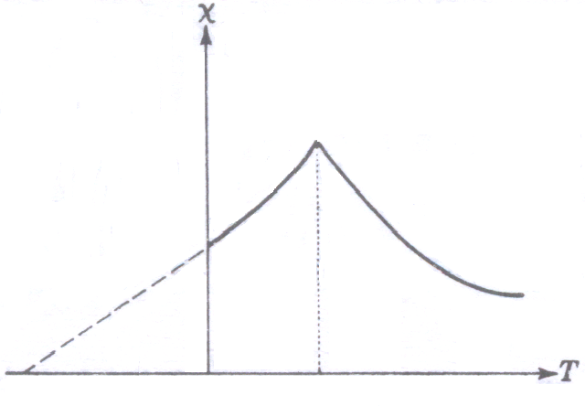
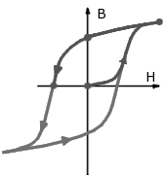
(i) (ii)

(3 + 2)

___________________________________________________________________________

