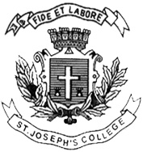ST. JOSEPH’S COLLEGE (AUTONOMOUS), BANGALORE-27
DATE: 6-04-2018 (9am)
END SEMESTER EXAMINATION: APRIL 2018
OPEN ELECTIVE: IV SEMESTER

VCOE 4116: Reading Images

Time - 1 ½ hrs Max Marks – 35
(For supplementary candidates)
Do not write the register number on the question paper
Please attach the question paper along with the answer script.

This paper contains ONE printed page and TWO parts
- Write short notes on any THREE of the following in 100 words each. (3X5=15)
1. Icon vs index
2. Syntagmatic vs paradigmatic
3. Marxist analysis
4. Feminist analysis
5. Ways of Seeing

- Answer any TWO of the following questions in 300 words each. (2X10=20)
6. “Images have become more interesting than the original and in fact have become the original: ‘the shadow becomes the substance’. Elucidate using appropriate examples.
7. “The “male gaze” invokes the sexual politics of the gaze and suggests a sexualised way of looking that empowers men and objectifies women.” Do you agree with the aforementioned statement? Discuss and substantiate your arguments with examples.
8. Attempt a semiotic analysis of the following print advertisement for Diet Pepsi.
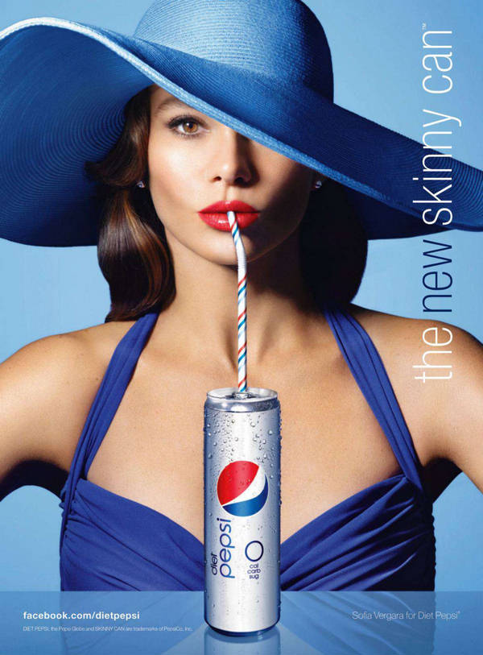. VC-4116-A-18

