DATE:8-4-19

**ST. JOSEPH’S COLLEGE (AUTONOMOUS), BANGALORE-27**

**B.Com –II SEMESTER**

**END SEMESTER EXAMINATION, APRIL 2019**

**BC 2116 : Financial Accounting**

**Time: 2 ½ Hours Max Marks: 70**

**This paper contains two printed pages and four parts**

**SUPPLEMENTARY CANDIDATES ONLY**

**ATTACH THE QUESTION PAPER WITH THE ANSWER BOOKLET**

**Section A**

**I Answer any five of the following (5 X 2 = 10 marks)**

1. What is minimum rent?
2. Why average clause included in fire insurance policy?
3. Mention two objectives of branch accounting
4. Distinguish between cost price and loaded price
5. Define goodwill
6. List out any four factors affecting value of shares
7. What is fair value measurement in shares? Give example

**Section B**

**II Answer any three of the following (3 x 5 = 15 marks)**

1. Mr. Raman wrote a text book on Accountancy and got it published through Keerti book hourse on 1.1.2011 on the following terms.

Royalty Rs 10 per copy sold, subject to a minimum of Rs 50,000 p.a. allowing the book house to recover any short workings during the first four years. Other details are

|  |  |  |
| --- | --- | --- |
| **Year** | **No of copies printed** | **Closing stock** |
| 2011 | 3,000 | 1,000 |
| 2012 | 4,000 | 2,000 |
| 2013 | 8,000 | 3,000 |
| 2014 | 5,000 | 1,500 |
| 2015 | 6,000 | 500 |

Prepare analytical table.

1. On 15th June, 2015 a fire occurred in the premises of a firm. From the following particulars ascertain the amount of claim to be lodged in case of loss of stock which was insured:

|  |  |
| --- | --- |
|  | Rs. |
| Stock on 1-4-2015  Purchases from 1-4-2015  Wages  Manufacturing expenses  Sales from 1-4-2015 to date of fire | 70,00,000  1,05,00,000  35,00,000  21,00,000  1,68,,00,000 |

Rate of gross profit is 33.33% on cost. The stock salvaged was valued at Rs. 2,10,000.

1. Mumbai H.O. has a branch in Chennai to which goods are invoiced by the H.O. at cost plus 25% cash received by the branch is daily remitted to H.O. All expenses of branch are paid from Mumbai H.O. From the following details prepare Chennai branch account is H.O. Books.

|  |  |  |
| --- | --- | --- |
| Stock on 1.4.2012 at invoice price  Debtors on 1.4.2012  Goods invoice from Mumbai at invoice price  Remittances to Mumbai:  Cash sales  Cash from debtors  Goods returned to HO at invoice price  Cash received from Mumbai for :  Wages and salaries  Rent  Sundry expenses  Stock on 30.9.2012 at invoice price  Debtors on 30.9.2012 | Rs.  16,000  29,500  11,000  3,000  510 | Rs.  12,500  12,000  40,000  45,500  2,400  14,510  15,000  22,500 |

1. Abc ltd purchased the business of XYZ ltd. The appropriate weights are

2001-1,2002-2.5,2003-3.8 and 2004-4.2.

The profits for these years were Rs.40500, Rs.60000, Rs.75000 respectively. On scrutiny of accounts, the following aspects were revealed:

1. The company purchased new furniture on 30thjune 2003 which was entered in purchase day book. The value furniture was Rs.10000. for the purpose of goodwill the error has to be rectified and depreciation should be provided at 10% under written down value method.
2. The opening stock of year 2003 was under valued by Rs.2500
3. Anticipated additional expenses in administration is Rs.5000.

Calculate goodwill on the basis of 3 years purchase of weight average for 4 years.

1. Write journal entries in the books of Head Office as well as the branch as on31/12/2015

a. The Head Office had sent goods on 27/12/15 worth 1000 to the branch, whichreceived these goods on 4.1.2016.

b. On 28/12/15, the branch had remitted Rs. 750 to the Head office, whichreceived the amount on 6/1/16

c. Depreciation on branch asset was Rs.400. The account of these assets was keptin the books of the Head Office

d. A clerk of the branch had rendered services worth Rs.600 in the head office,his salary was paid by the branch

e. The branch paid Rs100 dividend to a local shareholder on behalf of the headoffice.

**Section C**

**III Answer any three of the following** (**3 x 10 = 30 marks)**

1. AB coal ltd has taken on lease coal fields from Y ltd, on the following terms
2. Lease is for 99 years
3. Lease rent is to be 50 paise per annum for every tone of coal raised
4. Minimum royalty per annum is to be Rs.30,000 the lessee has a right to recoup any shortworking within a period of three years for which the excess payment was made.
5. In case the working of the mines was affected by any strike or riot and there were no raisings, then minimum rent payable would abate proportionately.
6. The following were the raisings for the different years:

|  |  |
| --- | --- |
| 2012  2013  2014  2015  2016  2017 | 20,000 tonnes  35,000 tonnes  30,000 tonnes (there was a strike for three months during which no coal was mined)  70,000 tonnes  80,000 tonnes  1,00,000 tonnes |

You are required to show the royalties, shortworkings and the landlord’s accounts in the books of AB coal ltd.

1. On July 2015, Mr.Bean’sgodown was destroyed by fire. The records of the

company revealed the following particulars.

Stock on January 1, 2014 9,50,000

Stock on December 31, 2014 8,00,000

Purchases during 2014 31,00,000

Sales during 2014 40,00,000

Purchases from January to July 2015 7,50,000

Sales from Jan to July 2015 10,00,000

In valuing the closing stock of 2014, Rs.10,000 was written off on goods whose cost

was Rs48,000. A part of this stock was sold in 2015 at a loss of Rs.4000 on the

original cost of Rs24,000. Stock salvaged was Rs.50,000. The godown was fully

insured.

You are required to calculate the amount of claim to be lodged.

1. The big brother company, Bangalore has a branch at hubli which maintain its own books of accounts. The following trial balance has been prepared by the Hubli branch on March 31st, 2016.

|  |  |  |
| --- | --- | --- |
|  | Dr. (Rs.) | Cr. (Rs.) |
| Head office account  Opening stock  Purchases  Goods from H O  Sales  Goods returned to the H.O.  Salaries  Debtors  Creditors  Rent  Sundry Expenses  Cash at bank  Furniture  Depreciation on furniture | 11,664  21,600  352,000  68,400  16,200  13,320  7,056  5,292  6,488  21,600  1,440 | 4,96,800  21,600  6,660 |
|  | 5,25,060 | 5,25,060 |

Closing stock at the branch Rs.27,720.

Prepare the hubli branch trading and profit and loss account for the year ended march 31st March, 2016 and balancesheet of the Hubli branch on the above date.

1. Following is the balancesheet of sharad ltd., for year ended 31st March 2017:

|  |  |  |  |
| --- | --- | --- | --- |
| Liabilities | Rs. | Assets | Rs. |
| Capital:10000 shares of Rs.10 each  Reserves and surplus:  Profit & loss A/c 10000  Profit for 2016-17 80000  7% debentures  Creditors | 1,00,000  90,000  70,000  40,000 | Buildings  Machinery  Debtors  Stock  Cash | 1,00,000  50,000  50,000  40,000  60,000 |
|  | 3,00,000 |  | 3,00,000 |

Normal rate of return on average capital employed is 10%. Find out the value of goodwill on the basis of 2 years purchase of super profit. Buildings are revalued at Rs.1,50,000 and machinery at Rs.40,000. All other assets are worth their book values.

1. Following is the balance sheet of fast grow ltd. As on 31st march 2017:

|  |  |  |  |
| --- | --- | --- | --- |
| liabilities | Rs. | Assets | Rs. |
| Share capital  3000, shares of Rs.100 each  General Reserve  Profit and loss A/c  Creditors  Provision for taxation  Provident fund | 3,00,000  50,000  25,000  40,000  20,000  10,000 | Land & buildings  machinery  Investment at cost  (market value of Rs.40000)  Debtors  Stock  Cash | 1,50,000  1,00,000  45,000  1,00,000  40,000  10,000 |
|  | 4,45,000 |  | 4,45,000 |

Additional information

1. Goodwill is taken at Rs.50000
2. Depreciate machinery at 10% and increase land and buildings to Rs.180000
3. Provide 8% towards bad debts.
4. 20% is the normal rate of dividend declared by similar type of business on their paid up capital, however the company could declare only 18% dividend for the current year.

Calculate the intrinsic value of shares of the company.

**Section D**

IV **Compulsory Question (1 X 15 = 15 marks)**

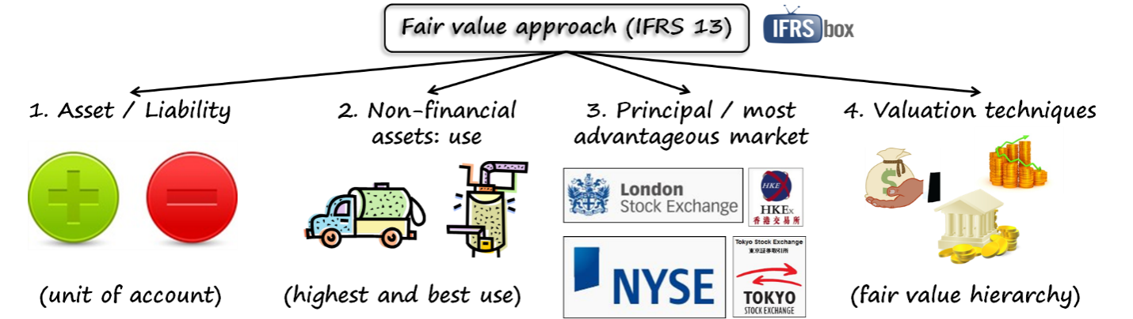

Interpret in detail the above figures through practical examples

BC 2116-A-18