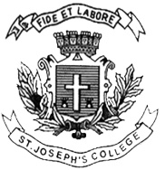
Register Number:
DATE:
ST. JOSEPH’S COLLEGE (AUTONOMOUS), BANGALORE-27
UG – IV SEMESTER
SEMESTER EXAMINATION: APRIL 2018
BT OE 4116 : Biotechnology Now and Beyond

Time- 1 ½ hrs Max Marks-35
This paper contains ONE printed page and THREE parts

- Answer any five of the following 1x5=5
- What are genes?
- Explain the use of Drosophila as a model organism
- What biotechnology concept was part of the movie Jurassic park?
- State any example of a gene introduced to create a transgenic animal.
- What are adverse drug reactions?
- What is patenting?
- What is Bioinformatics?

- Answer any two of the following 5x2=10
- Discuss Hershey Chase experiment.
- Explain the DNA model.
- What are the ethical issues faced in genetic engineering?

- Answer any two of the following 10x2=20
- What are the advantages of the product ‘Bt cotton’ for India?
- State and explain any four applications of DNA studies in forensics.
- How was Dolly the first cloned mammal constructed? What problems did it have?

