ST.JOSEPH'S COLLEG (AUTONOMOUS), BANGALORE-27
IV SEMESTER EXAMINATION, APRIL-2017
PAPER: CH 415; Chemistry - IV
TIME: 90 minutes Max. Marks: 35

This question paper contains TWO printed pages and three parts; Part-A, Part-B and Part-C.

Part-A
Answer any THREE of the following: 3 x2 = 6 marks

- Discuss briefly the variation of oxidation states of elements of oxygen family.
- Mention any two anomalous behaviour of fluorine.
- Give any two characteristics of a catalyst.
- Draw the structure of the following compounds:
(i) xenon hexafluoride (ii) XeO₃F₂ .
- Name the type of hybridization involved and mention the shape of the following molecules:
(i) xenon trioxide (ii) xenon tetrofluoride
PART-B
Answer any FOUR of the following: 4 x 6 = 24 marks

- Give the general outermost electronic configuration of the elements of the nitrogen family. Classify the oxoacids of phosphorus according to the oxidation state of phosphorus. Give the structure of (i) pyrophosphoric acid (ii) meta phosphoric acid and (iii) the structure of an oxoacid of phosphorus which is a reducing agent.
- (a) How would you prepare an aldehyde using an alkyl lithium compound?
(b) Discuss briefly the hybridization involved in ${ICl}_{2}^{-}$and draw its structure. (3+3)
- (a) Explain the mechanism of homogeneous catalysis by taking an example.
(b) With the help of a energy diagram explain the working of a catalyst. (3+3)
- (a) Draw a neat labeled phase diagram of potassium iodide-water system.
(b) Explain why a three dimensional phase diagram is need for a two component system. How do you overcome this difficulty for a condensed system? (3+3)
- Discuss the mechanism of formation of acetophenone from benzene and draw the energy profile diagram for the above reaction.
- (a) Although chlorine atome is electron withdrawing it is ortho, para director. Explain.
(b) Give the structure of (i) Marshall’s acid (ii) polythionic acid. (3+3)

PART-C
Answer any one of the following: 1 x 5 = 5 marks

- (a) What is the value of n in Huckel's rule when a cyclic compound has 2 pairs of π electrons? Is this compound aromatic?
(b) Classify the following chemical species into aromatic, antiaromatic and non-aromatic.
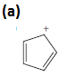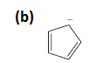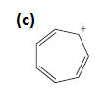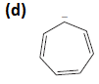
(e) (f)
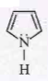 (2+3)

- Suppose you had the following phase diagram for a simple pure substance:

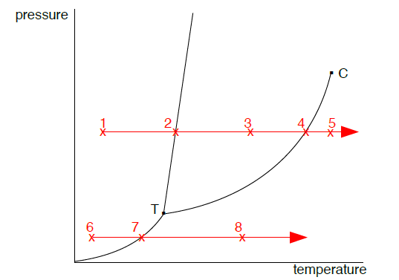

a) What physical state would the substance be in under the conditions at point 1?
b) Suppose the temperature of the substance was then increased at point 1 at constant pressure. What state(s) or equilibrium would the substance be at points 2 and 5?
c) Suppose the constant pressure was 1 atmosphere, what useful information can you get from the diagram at points 2 and 4 about the temperature of the substance?
d) Suppose at a much lower pressure, the substance was under the conditions at point 6. Describe what happens to the substance as you increase the temperature from point 6 to point 8.

xxxxxxxxxxx

