
Register Number:
DATE: 17-04-2017
ST. JOSEPH’S COLLEGE (AUTONOMOUS), BENGALURU-27
B.Sc. ELECTRONICS – II SEMESTER
END SEMESTER EXAMINATION: APRIL 2017

EL 215 - Amplifiers and Oscillators

Time- 2 ½ hrs Max Marks-70

This paper contains THREE printed pages and THREE parts
PART-A
ANSWER ANY FIVE OF THE FOLLOWING 5X8=40 Marks
- a) With the help of circuit diagram derive the expression for voltage gain of
Transformer coupled amplifier.
b) Give any three differences between RC and Direct coupled amplifier. (5+3)

- a) Explain and derive the expression for efficiency of class-B push pull power
Amplifier.
b) Give any three differences between voltage and power amplifier. (5+3)

- a) With the help of circuit diagram derive the expression for frequency of oscillations of Hartley oscillator.
b) Explain Barkhausean criterion for oscillation. (6+2)

- a) Explain the fabrication process of an npn transistor.
b) With the help of circuit diagram explain the working of IC 555 version of Astable multivibrator. (4+4)

- a) Derive the expression for voltage gain of a dual input balanced output differential amplifier.
b) Explain the working of current mirror circuit. (5+3)

- a) Explain the block diagram of operational-amplifier.
b) Explain the following i) slew rate ii) virtual ground (4+4)

- a) Derive the expression for output voltage of Integrator circuit, and also sketch the
output waveform for input square wave when the condition is satisfied.
b) With the help of circuit diagram explain the working of first order high pass filter
and draw the frequency response curve. (5+3)

EL-215-B-16

PART – B
ANSWER ANY FIVE OF THE FOLLOWING 5x4=20 Marks
- For the given circuit diagram determine the values of voltage gain of each stage and overall voltage gain.
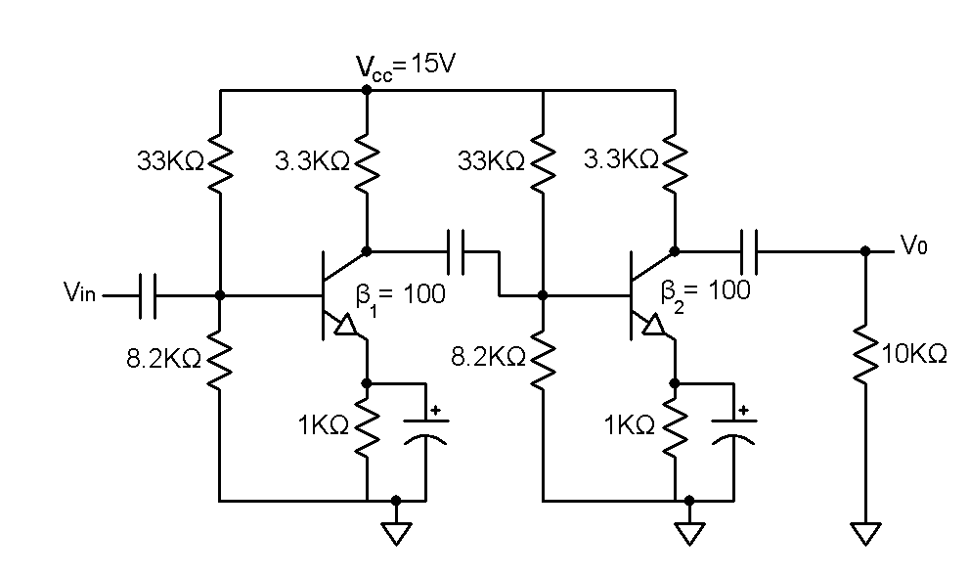

- An RC phase shift oscillator makes use of three RC sections with R = 1KΩ, C = 0.22µF. Calculate frequency of oscillations and mention the minimum gain needed for oscillations to occur.

- A crystal oscillator has the values of L_{s} = 3H, C_{s} = 0.05pF, R = 2KΩ and C_{m} = 10pF. Calculate f_{s} and f_{p} of the crystal.

- For the given dual-input balanced-output differential output amplifier. Given β_{dc} = β_{ac} = 100, V_{BE} = .715V.
- Determine the I_{CQ} and V_{CEQ} values.
- Determine the voltage gain.
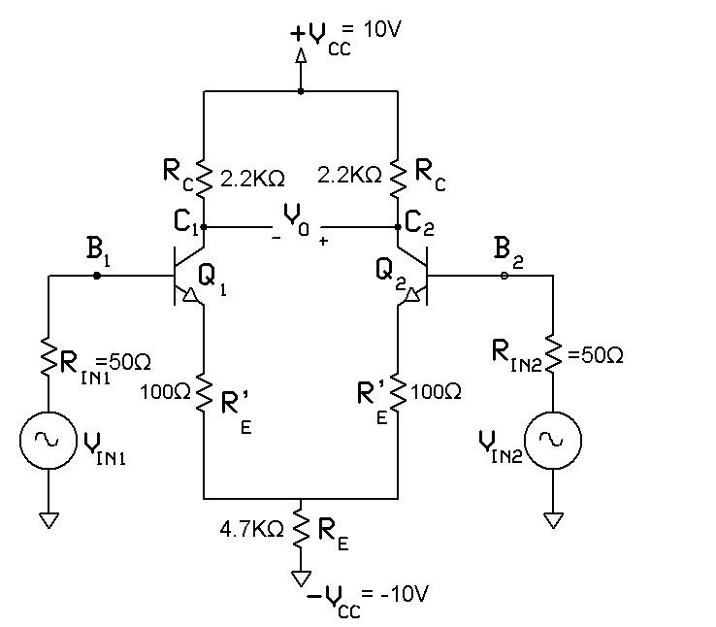

- For voltage follower circuit, Given A = 200,000, R_{i} = 2MΩ, R₀ = 75Ω, f₀ = 5Hz. Compute the values of A_{F},R_{iF},R_{oF},f_{F}.

- Find the output of the following circuit.

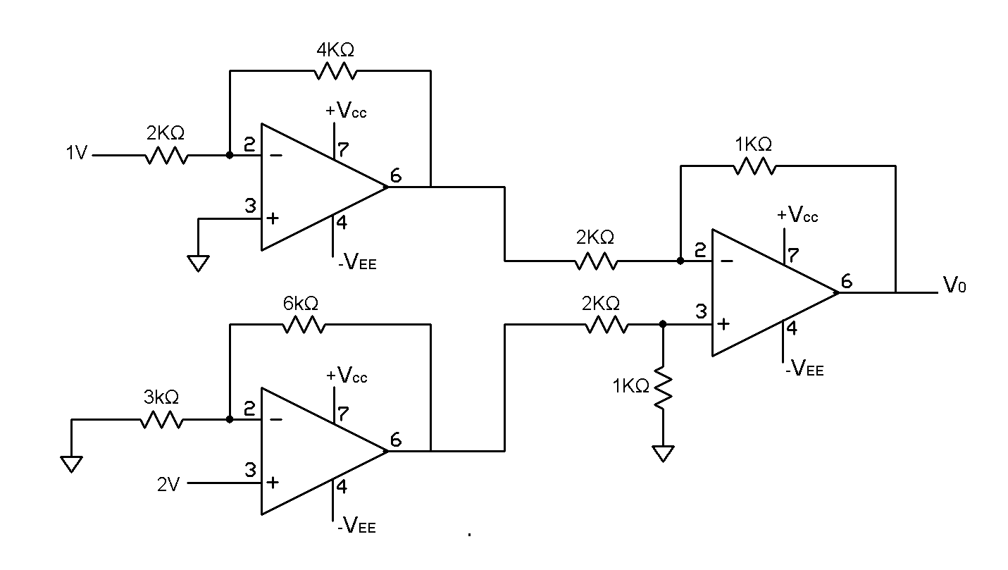

- Design a low pass filter at a cut-off frequency of 1KHz with a pass band gain of 2.

PART – C
ANSWER ANY FIVE OF THE FOLLOWING 5x2=10 Marks
- Why we need heat sinks in power amplifier, usually what kind of element is used?

- Which multivibrator is used to storing of binary information, why?

- Name the circuit whose output frequency can be changed by changing control input, what will happen to frequency if input voltage increases.

- Name the device which has adjustable negative voltage regulator, and mention the output voltage range.

- What are the four differential amplifier configurations? Which one is not commonly used, and why?

- What is the importance of CMRR? What is its ideal value?

- Name the circuit which is also called as zero crossing detector, and also sketch the input and output waveform.

